Week 8 Final Internship Documentation
Infosys Springboard Internship | Data Visualization Domain
Topic Focus: Final Dashboard Creation, DAX Practical Implementation, and Business Insights
Prepared by: Prabhakar Kumar Shahi
Project: Optimizing IT Support Team Performance Using Analytics


1. Introduction
Week 8 is the final and most important stage of the internship because it focuses on converting all the learning from previous weeks into a complete Power BI dashboard solution. During this week, the cleaned support ticket dataset was used to implement DAX practically, create real project-specific measures, define calculated columns where needed, build a Date table, apply time intelligence basics, and design the final interactive dashboard.
This week combines technical implementation with business presentation. It includes dashboard visual creation, slicers, filters, drill-down, visual interactions, formatting, and storytelling. It also documents the challenges faced while creating the dashboard and highlights the key business questions that the dashboard answers for the company.

2. Final Project Workflow
The final dashboard creation followed a structured workflow. The dataset was first cleaned and prepared in Power Query, then modeled for analysis, followed by DAX measure creation, visual development, interaction setup, and insight extraction.
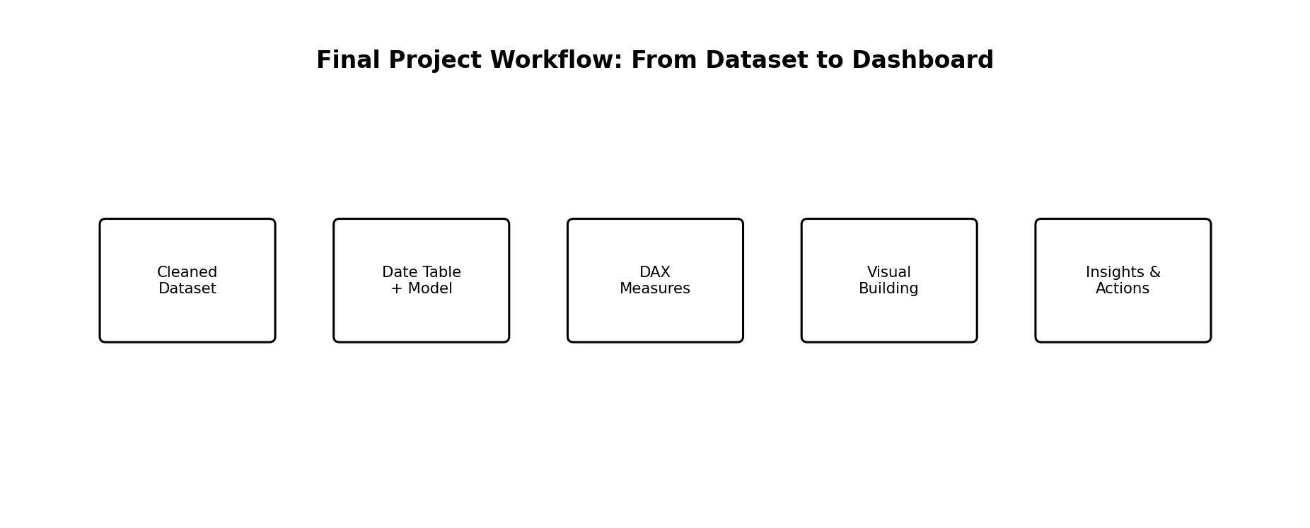
Figure 1: Final workflow used to convert the support ticket dataset into a business-ready dashboard
- Load the cleaned support ticket dataset into Power BI
- Verify data types and final quality checks
- Create a Date table for time-based analysis
- Create DAX measures and selected calculated columns
- Build KPI cards and analytical visuals
- Add slicers, drill-down, and interactions
- Format the dashboard for clarity and storytelling
- Validate insights and business questions answered

3. DAX Practical Implementation on the Actual Dataset
In Week 8, DAX was applied directly to the support ticket dataset rather than only learning theory. The goal was to create reusable, business-relevant measures that power the final dashboard. These measures were created to monitor workload, efficiency, quality, and service performance.
Measure Name | Suggested DAX Logic (Conceptual) | Purpose
Total Tickets | COUNT(ticket_id) | Total number of support tickets
Closed Tickets | CALCULATE([Total Tickets], status = 'Closed') | Completed support tickets
Open Tickets | CALCULATE([Total Tickets], status = 'Open') | Current unresolved workload
Pending Tickets | CALCULATE([Total Tickets], status = 'Pending Customer') | Tickets waiting for customer action
Avg First Response Time | AVERAGE(first_response_time_hours) | Average response efficiency
Avg Resolution Time | AVERAGE(resolution_time_hours) | Average issue resolution efficiency
Avg Satisfaction | AVERAGE(customer_satisfaction_score) | Average service quality score
Escalated Tickets | CALCULATE([Total Tickets], escalated = 'Yes') | Tickets requiring escalation
Breached Tickets | CALCULATE([Total Tickets], sla_breached = 'Yes') | Tickets violating SLA

4. KPI Measures for the Final Dashboard
After base measures were created, the next step was to create KPI measures that directly support business decision-making. These KPI measures were placed in cards and summary visuals on the executive dashboard page.
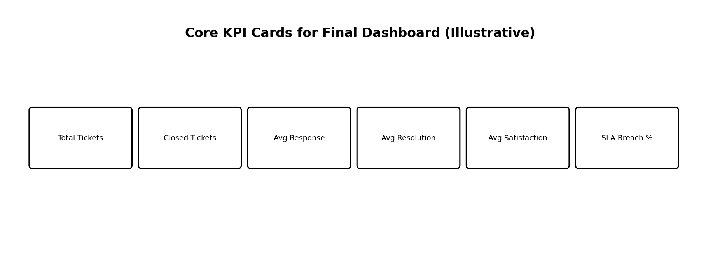
Figure 2: Core KPI cards designed for the final support ticket dashboard
KPI | Suggested Logic | Business Value
Resolution Rate % | DIVIDE([Closed Tickets], [Total Tickets]) | Shows how much work is completed
Open Ticket Rate % | DIVIDE([Open Tickets], [Total Tickets]) | Shows current backlog pressure
Pending Ticket Rate % | DIVIDE([Pending Tickets], [Total Tickets]) | Shows waiting dependency on customer
Escalation Rate % | DIVIDE([Escalated Tickets], [Total Tickets]) | Measures complexity / escalation load
SLA Breach Rate % | DIVIDE([Breached Tickets], [Total Tickets]) | Measures service compliance risk
Urgent Ticket Count | CALCULATE([Total Tickets], priority = 'Urgent') | Critical ticket workload

5. Calculated Columns Used in the Project
Although measures are preferred for most dashboard metrics, a few calculated columns can be useful in the project for grouping, labeling, and simplifying report logic.
Calculated Column | Purpose
Resolution Status Group | Group tickets into Resolved vs Unresolved
Response Time Bucket | Classify first response time into Fast / Moderate / Slow
Resolution Time Bucket | Classify resolution time into Quick / Average / Delayed
Customer Age Group | Group customers into age ranges for analysis
Complexity Band | Group issue complexity into Low / Medium / High
SLA Status Label | Create a readable label such as Breached / Within SLA
These calculated columns are helpful for segmentation and easier slicing, but they should be used carefully because too many calculated columns can increase model size.

6. Date Table and Time Intelligence Basics
A proper Date table is highly recommended in Power BI for professional analysis. In this project, the Date table can be connected to ticket_created_date and used for trend analysis, monthly comparisons, and time intelligence.
- Create a Date table covering the full ticket date range
- Include Year, Quarter, Month, Month Number, Week, and Day columns
- Mark it as a Date Table in Power BI
- Relate it to the ticket created date for main trend analysis
Time Intelligence Use | Application in This Project
Monthly Ticket Trend | Track ticket volume over months
Monthly Avg Response Time | Compare service speed over time
Monthly Avg Resolution Time | Monitor efficiency trend
Monthly SLA Breach Rate | Track compliance improvement or decline
Monthly Satisfaction Trend | Understand customer experience changes
Even if advanced year-over-year comparison is not fully required in the current project, the use of a Date table makes the dashboard more professional and future-ready.

7. Dashboard Visual Building with These Measures
After measures and supporting columns were created, the final dashboard visuals were built. The visuals were selected based on the business questions and KPI needs identified in earlier weeks.
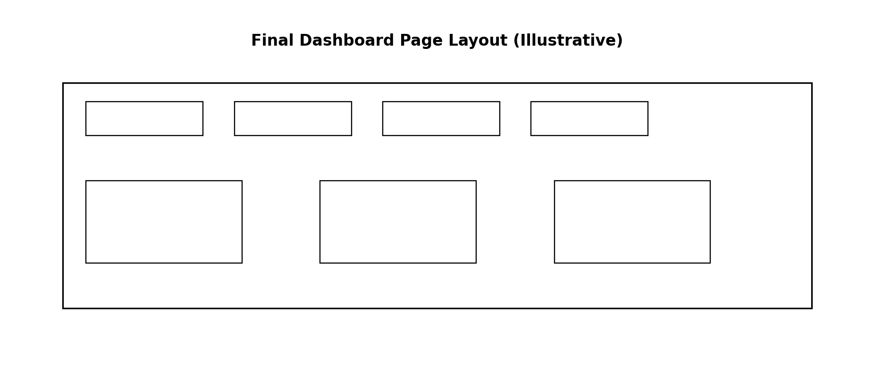
Figure 3: Example layout used for the final dashboard page design
Visual | Fields / Measures Used | Purpose
KPI Cards | Total Tickets, Closed Tickets, Avg Response, Avg Resolution, Avg Satisfaction, SLA Breach % | Executive summary
Line Chart | Date vs Total Tickets | Trend over time
Donut Chart | Status distribution | Open vs Closed vs Pending overview
Bar Chart | Priority vs Ticket Count | Urgency distribution
Bar Chart | Category / Product vs Ticket Count | Identify support burden areas
Column Chart | Channel vs Avg First Response | Compare response performance
Column Chart | Region vs SLA Breach Rate | Regional compliance analysis
Scatter Plot | Resolution Time vs Satisfaction | Quality-efficiency relationship

8. Slicers, Filters, and Drill-Down
To make the dashboard interactive and user-friendly, slicers and filtering options were added. These features allow business users to explore the data based on their own focus area.
- Recommended slicers: Date, Region, Priority, Status, Channel, Product, Customer Segment, Subscription Type
- Use dropdown slicers for high-cardinality fields
- Use horizontal slicers for small fields like Status or Priority
- Enable drill-down in time-based visuals (Year → Quarter → Month) if Date hierarchy is used
- Use chart-level filters for focused operational visuals

9. Interactions, Formatting, and Dashboard Storytelling
A professional dashboard must not only show data but also communicate insights clearly. For this reason, visual interactions, layout, formatting, and storytelling principles were applied while building the final dashboard.
- Keep KPI cards at the top for immediate executive understanding
- Place trend and distribution visuals in the middle section
- Place diagnostic visuals such as category, channel, and region comparisons in the lower section
- Use consistent fonts, spacing, and alignment
- Avoid excessive visual clutter
- Use business-friendly titles instead of only technical field names
- Control interactions so that visuals do not filter each other in confusing ways

10. Questions Answered by the Dashboard
- How many total support tickets are being raised?
- What percentage of tickets are Closed, Open, or Pending Customer?
- What is the average first response time of the support team?
- What is the average resolution time of tickets?
- What is the average customer satisfaction score?
- What percentage of tickets breach SLA?
- How often are tickets escalated?
- Which ticket priorities create the highest workload?
- Which categories or products generate the most support tickets?
- Which channels respond fastest or slowest?
- Which regions show more SLA breaches or delays?
- Does longer resolution time reduce customer satisfaction?
- Which customer segments or subscription types require more support attention?

11. Difficulties Faced While Creating the Dashboard
During the creation of the final dashboard, several practical challenges were encountered. These difficulties are normal in real-world analytics projects and helped strengthen the understanding of Power BI development.
- Single flat table made professional modeling more difficult compared to a multi-table schema
- Some columns required careful data type correction before DAX worked correctly
- Handling blanks in resolution_time_hours and ticket_resolved_date needed business logic
- Choosing whether to use measures or calculated columns for some classifications required careful decision-making
- Some visuals became cluttered when too many categories were shown together
- Controlling visual interactions required testing to avoid confusing cross-filter behavior
- Time intelligence required a proper Date table instead of relying only on raw date fields
- Balancing technical completeness with clean dashboard design was a challenge

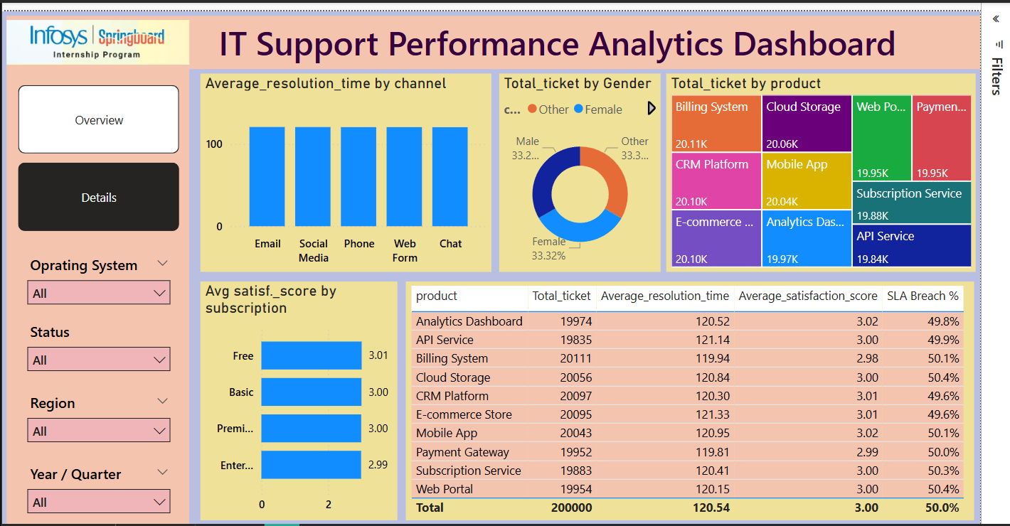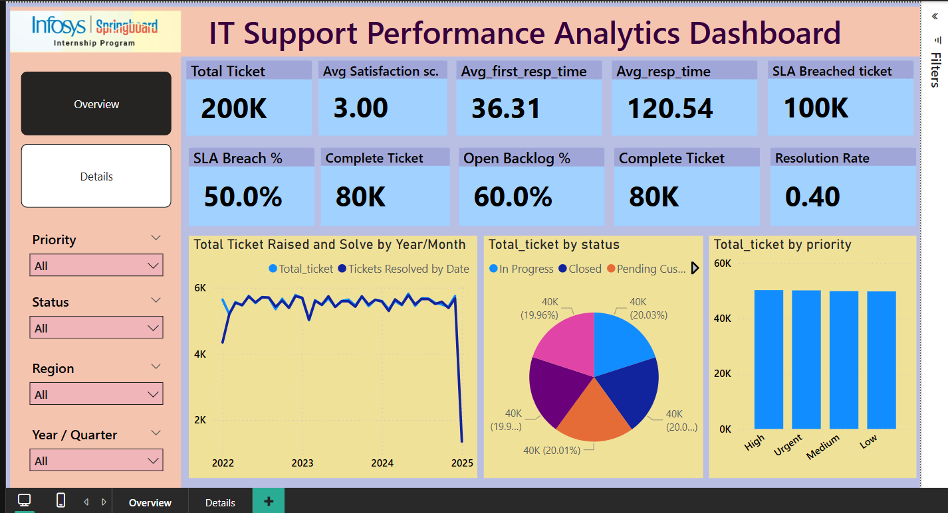

13. Final Business Value of the Dashboard
The final dashboard provides business value by converting raw support ticket records into actionable insights. Management can quickly see whether the support team is meeting service expectations, where delays are happening, which products or categories create the most operational burden, and how service quality affects customer satisfaction.
- Helps monitor operational workload
- Identifies delays in response and resolution
- Highlights SLA risk and escalation trends
- Supports resource allocation by region, channel, and priority
- Improves customer experience monitoring through satisfaction analysis
- Provides a structured decision-support system for IT support optimization

14. Week 8 Final Learning Summary
Week 8 completed the internship by combining data preparation, modeling, DAX, and dashboard design into one final analytical solution. Real measures were created on the actual support ticket dataset, KPI measures were defined for executive reporting, selected calculated columns were added for grouping, and a Date table was introduced for time-based analysis. These elements were then used to build the final Power BI dashboard with interactive visuals, slicers, filters, and drill-down capabilities.
This final week also highlighted practical challenges such as handling blanks, choosing the right calculation type, managing interactions, and balancing clarity with technical depth. Overall, the final dashboard demonstrates how analytics can be used to optimize IT support team performance in a professional and business-focused way.

15. Conclusion
Week 8 is the culmination of the internship project and represents the successful conversion of a raw support ticket dataset into a professional Power BI dashboard. Through practical DAX implementation, KPI development, calculated columns, time-based analysis, interactive filtering, and storytelling-based dashboard design, the project achieved its main objective: to build an analytical solution that helps improve IT support team performance. This final dashboard can support management in tracking workload, efficiency, SLA compliance, escalation patterns, and customer satisfaction, thereby creating real business value.

